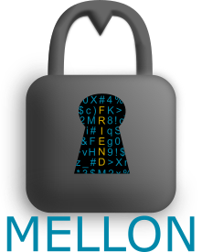

User Guide

# **About Mellon**

Mellon is a password generation and storage tool which creates strong, complex passwords and securely stores usernames and passwords to all of your accounts.

Mellon stores your information in a hashed file in a secure database. We never see any of your passwords or your master password, and even if the database is hacked, the intruders would only obtain the encrypted file. Encryption and decryption is done on your computer, so your passwords and usernames are never transmitted in a readable format.

A lot of data gets transmitted on the internet. Protect yourself and your data with as strong a password as possible. Mellon makes this easy, so use strongest password the website or account will allow.

# **Using Mellon**

## **Creating an Account and Logging In**

When you open Mellon for the first time, you’ll be greeted by the login page. To create an account, select the Sign Up button. Once on that page, choose a username and password. To ensure the security of your information, passwords must be a minimum of 12 characters and contain at least one (1) symbol, one (1) number, and one (1) of each upper and lower case letters.

Once you have filled out the form, hit submit. If the username is not already taken and everything goes smoothly, you will be taken back to the login page to sign in for the first time.

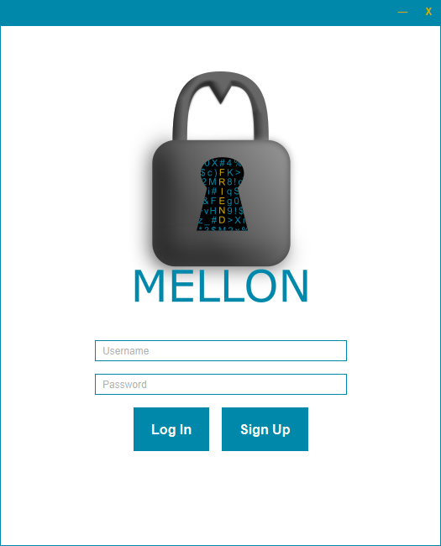 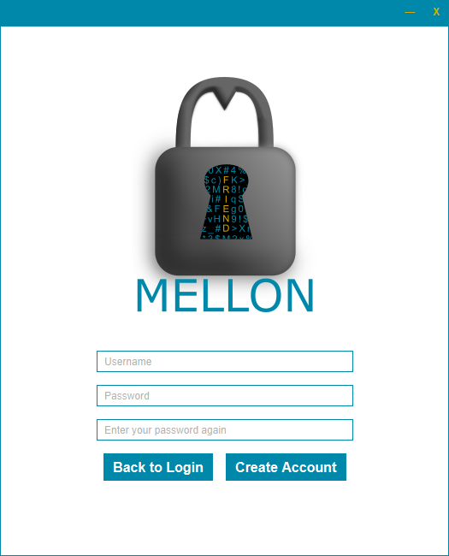

## **Learning the Navigation Bar**

Once you log in, you will find the navigation bar along the top of the window. We’ll explain these buttons, but you will primarily use the home, create, and log out buttons.

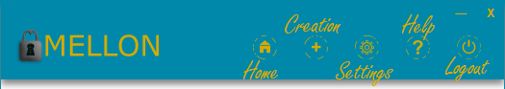

## **Creating a New Profile**

To create a profile, select the '+' icon from the navigation bar. This will display the creation menu. Ensure all of the fields are filled out, choose your password options, hit generate (or enter your own), and save. It's that easy.

**Nickname:** This is the name you will use to find your account once it is created. Use something like "Gmail" or "Facebook".

**Username:** This is the username of the account you are adding. For example, your email address.

**Password length:** This is the length of the password to generate (if you generate your own). You can select from a pre-set selection, or choose "Custom" to enter your own length as needed.

**Set Expiration:** You can choose to set a reminder to change your password. You will be reminded three days from the expiration date, and prompted to change your password after it expires. Note: the expiration date is simply a reminder, the password does not actually expire in Mellon.

**Quick Customize:** Choose whether to allow symbols, numbers, upper, or lowercase characters in the generated password. If your account has restrictions on allowable characters (e.g. it only allows letters, numbers, and '!'), you can click the "Advanced" button to open a menu of all special characters. Simply check the ones you want to allow, and save the settings.

**Generate Password:** You can enter a password on your own, or use Mellon's random generator to create a password meeting the above settings. The choice is yours.

**Save Account:** Saves the profile to the database and returns you to the main menu.

## **Retrieving a Profile’s Information**

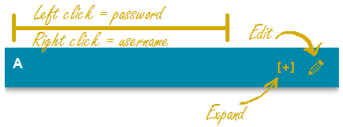In Mellon, getting your passwords is as easy as a click of your mouse.

Once you have created at least one profile, your profiles will be displayed on the main menu. Clicking on the profile will automatically copy your password to the clipboard, and you can be on your way. If you need to copy your username, simply right-click on the profile and it will automatically be copied.

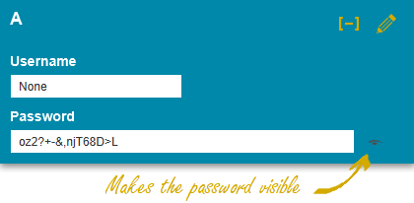If you want to view your profile information, simply click the [+] to expand the profile. Your password will initially be blurred out, so click on the eye icon to view it. Clicking on the password field will also copy the password to the clipboard.

## **Editing a Profile**

Sometimes you need to make a change. In Mellon, changing your profile is easy. Simply select the pencil icon next to the profile you want to change. This will take you to the same menu you used to create the password, but this time will pre-populate the fields with information from your profile.

Make changes as desired using the same methods you used to make the profile, and click save. You can also delete your profile from this menu.

**IMPORTANT:** Changing your password permanently erases the old password from the profile. Since Mellon never sees the password, we cannot retrieve the old one after it is overwritten. Changing your password in Mellon does not change the password in the actual account. Be sure to change your password in the actual account before saving the changes in Mellon.

## **Adjustable Settings**

Mellon contains a few user settings to make things easier on you. Click on the cog icon to open the settings menu.

**Timeout duration:** This is how long the program will sit idle before logging you out for security purposes. The default is 10 minutes.

**Password length:** This is the default password length for Mellon's password generator. The default is 16 characters, but you can change it to whatever you like. You will always have the option to choose the password length in the creation menu if a particular account has a short password length requirement.

**Change your master password:** Be sure to pick a strong password and write it down if you need a reminder.

**Print a physical copy of your stored passwords:** If you want a back up to take on the road or are skeptical of technology, you can print a copy of your passwords from the settings menu. Do not make a digital copy of your passwords, store the physical copy in a secure location.

## **Bugs and Program Help**

If you need a refresher on anything above, you can use the in-app help menu. Information on how to report a bug is also in the help menu. Try as we might, we’re not perfect. If you experience a problem using Mellon and it doesn’t go away, please let us know by reporting the bug.

## **Logging out**

Mellon will automatically log you out after a period of inactivity. This period is 10 minutes by default, but you can change it in the settings menu. If you are done with the program, you can select the X in the upper corner to log out and close the window, or simply select the log out button to return to the main men.

# **General Tips**

* Use as strong of a password as the website will allow. Mellon does the hard work of remembering it for you, so there’s no reason to make it easy for hackers.
* Do not make a digital copy of your Mellon password. If you need a reminder, write it down and store it in a secure place. Remember, if you forget this password, you will need to make a new Mellon account. **We cannot retrieve your Mellon password (or any of your passwords, for that matter).**
* Use two-factor authentication (e.g. a phone number) if possible to increase your security.
* **We cannot retrieve any of your information, so make sure you remember your master password. Did we say that already?**
* Be sure to check back for updates!